HOLD THE DATE !!
SUNDAY, JANUARY 21st, 2024,
9 a.m.-5 p.m.
THE EIGHT TEX CAUTHEN / HANS ALBRECHT FARRIER / VETERINARIAN / RESEARCHER SEMINAR

“EQUINE SAFETY AND OPTIMAL BIOMECHANICS OF SURFACE / HOOF / TENDON INTERACTIONS
LIVE in the GLUCK Auditorium and via ZOOM:
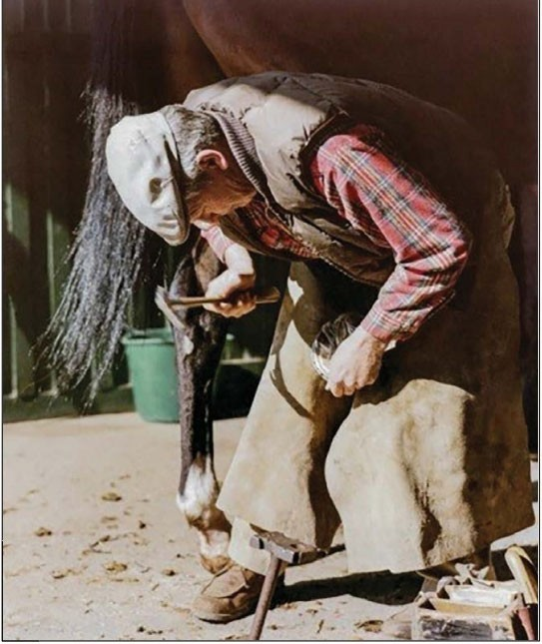

Registration link https://t.ly/P2NE

